# **CTF Challenge: Network Scanning - Using Ping.eu**



# **1. Introduction**



Ping. EU provides various network tools such as Ping, Traceroute, DNS Lookup, and more. This challenge will introduce you to using Ping. eu to gather DNS-related information about a target website.

# **2. Tools and Requirements**

* Access to the internet and search for Ping. eu

# **3. Scenario**

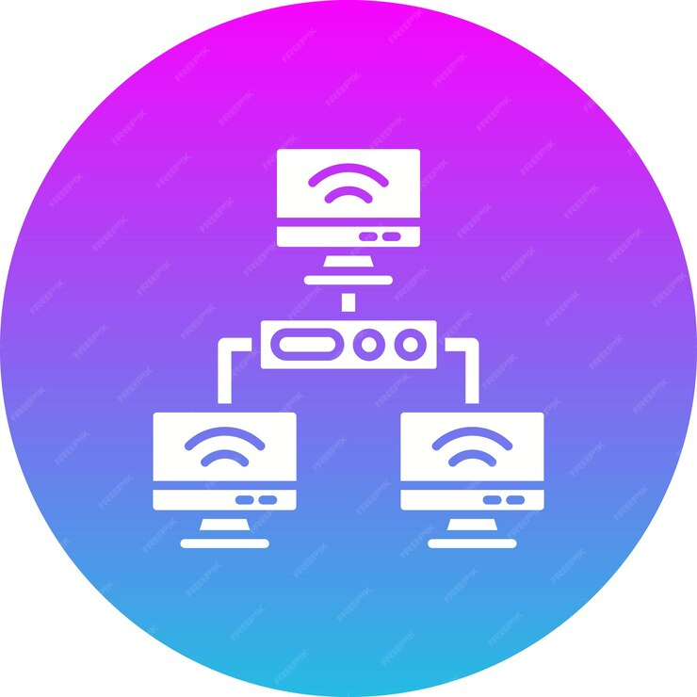

You are an ethical hacker tasked with assessing the Network Calculator configuration of a target domain using Ping.eu. Your job is to find the Network Calculator of the targeted IP Address.

# **4. Process to follow while performing CTF**

Step 1: Go to Ping.eu [**https://ping.eu/**](https://ping.eu/)select on Network Calculator.

Step 2: Network calculator: Enter the URL of the target domain **104.21.3.150** and start the search.

Step 3: Solve the CTF.

# **5. Let’s Begin the Challenge**

**Question**

**Flag 1: What is the Netmask of provided IP Address?**

*Answer: 24*

**Flag 2: What is the Broadcast IP Address?**

*Answer: 104.21.3.255*

**Flag 3: Which class IP have been Used?**

*Answer: Class A*

**Hint**

Use the "DNS Lookup" tool on Ping.eu to perform the analysis.

